# TEST CASE PREPARATION

# **Test Plan Id:**

FACE_ST_TP_001

# **Test Items:**

* Registration
* Sign in

**Prepare Test Scenarios:**

|  |  |
| --- | --- |
| **Test_Case ID** | **Test Scenarios** |
| TC_FaceBook_Login_001 | Validate the Facebook application for logging in |
| TC_FaceBook_RegistrationValidation_002 | Validate the Facebook application for registration |

**Test case development:**

## Login test case

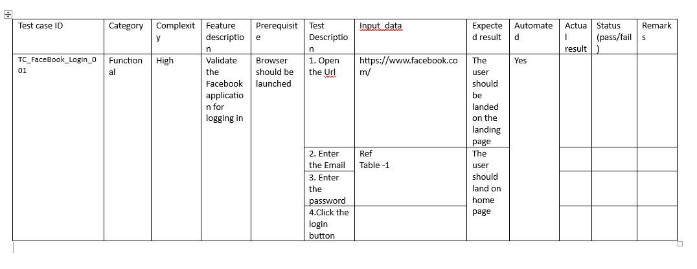

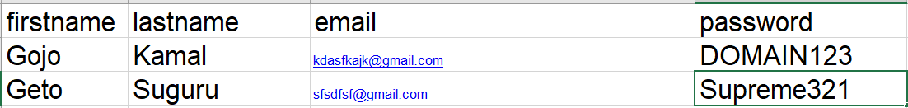

Table 1

## Registration test case

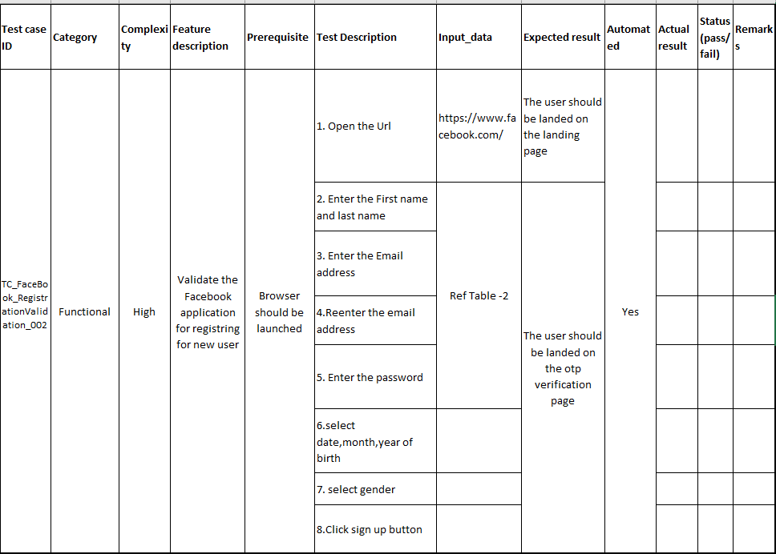



Table 2

# **Validation Table:**

|  |  |  |
| --- | --- | --- |
| **Test Case Id** | **Input Data** | **Expected Values** |
| TC_FaceBook_Login_001 | iuweoruower123@gmail.com, Ajithkumar47 | Opens up the homepage of Facebook |
| 11asdfkjsadf@gmail.com, vijay123kanth | Opens up the homepage of Facebook |
| [legend@gmail.com](mailto:legend@gmail.com), legend6999 | Opens up the homepage of Facebook |

|  |  |  |
| --- | --- | --- |
| **Test Case Id** | **Input Data** | **Expected Values** |
| TC_FaceBook_Registration  Validation_002 | Name: Vijay kanth ,  Email: [11asdfkjsadf@gmail.com](mailto:11asdfkjsadf@gmail.com) password: vijay123kanth | Opens up the OTP verification page |
| Name: Ajith Kumar ,  Email: iuweoruower123@gmail.com password: Ajithkumar47 | Opens up the OTP verification page |
| Name: Legend ,  Email: [legend@gmail.com](mailto:legend@gmail.com) password: legend6999 | Opens up the OTP verification page |